Chapter 2
Display System

Refresh or Raster Scan Display System
- In its simplest form, a raster consists of a matrix of cells (or pixels) organized into rows and columns (or a grid) where each cell contains a value representing information, such as intensity level.
- In this display system, raster points are used as basic drawing primitives.
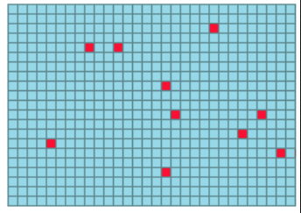
Fig: Raster Points
- Make use of scan line to draw pictures.
- In raster-scan the electron beam is swept across the screen, one row at a time from top to bottom.
- Picture definition is stored in a memory called frame buffer or refresh buffer.
- Frame buffer holds all the intensity value for screen points.
- As electron beam moves across each row, the beam intensity is turned on and off to create a pattern of illuminated spots.
- Refreshing on raster-scan displays is carried out at the rate of 60 to 80 frames per second. Refreshing must be done because light emitted by phosphor fades very rapidly, so to keep the drawn picture glowing constantly; it is required to redraw the picture repeatedly and quickly directing the electron beam back over some point. The no of times/sec the image is redrawn to give a feeling of non-flickering pictures is called refresh-rate.

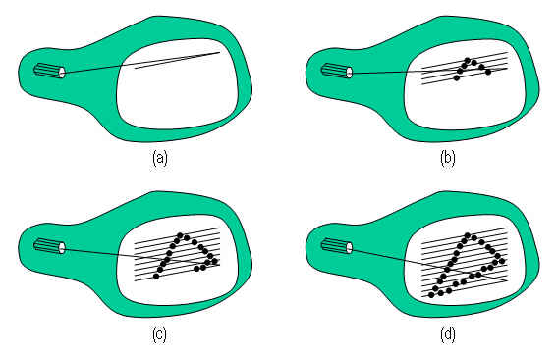

- Each scan line in display device consists of two retrace
- Horizontal retrace
- At the end of each scan line, the electron beam returns to the left side of the screen to begin displaying the next scan line. This is called horizontal retrace.

- Vertical retrace
- At the end of each frame, the electron beam returns to the top left corner to begin the next frame. This is called vertical retrace.
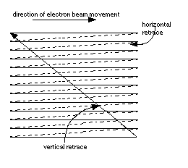
- On some raster-scan system each frame is displayed in two passes using and interlaced refresh procedure. In the first cycle the beam sweeps across odd scan line from top to bottom (1, 3, 5 and so on). Then after vertical retrace, the beam sweeps out the remaining even scan lines (2, 4, 6 and so on). This technique allows us to see the entire screen displayed in one-half the time it would have taken to sweep across all the lines at once from top to bottom. Interlacing is primarily used with lower refreshing rate. This is a very good technique for avoiding screen flickering; this is because adjacent scan lines contain similar display information.
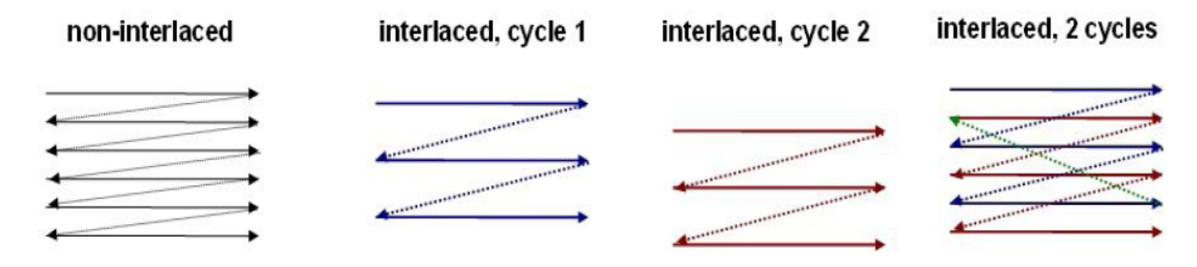
- Home television (CRT) and printers are example of systems using raster scan method.

Architecture of Raster Scan Display System
- A special purpose processor, called video controller or display controller is used to control the operation of the display device.
- The below figure shows the commonly used raster system organization.
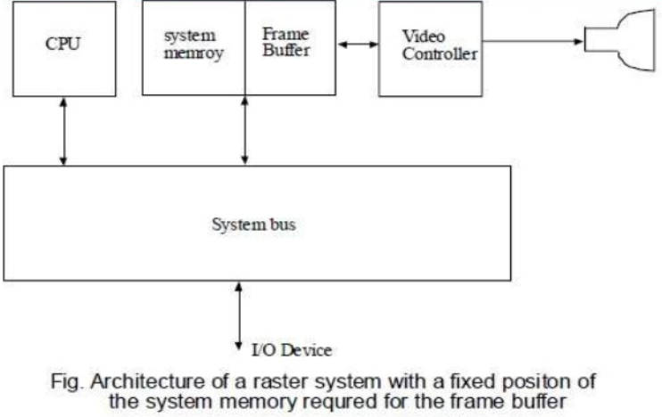
- A fixed area of memory is reserved for frame buffer, and the video controller is given direct access to the frame buffer
- When a particular command is called by the application program, the graphics subroutine package sets the appropriate pixels in the frame buffer.
- The video controller then cycles through the frame buffer, one scan line at a time, typically 50 times per second.
- It will bring a value of each pixel contained in the frame buffer and uses it to control the intensity of the CRT electron beam.
- So there exists a one to one relationship between the pixel in frame buffer and that on the CRT screen.
- Frame buffer locations, and the corresponding screen position are referenced in Cartesian co-ordinates.

- For most of the system, the coordinate origin is referenced at the lower left corner of the screen, with positive X value increasing to the right and positive y value increasing from bottom to top. However, in some PC, the coordinate origin is referenced at the upper left corner of the screen, so the y values are inverted.
- The below figure shows the basic refresh operation of video controller.
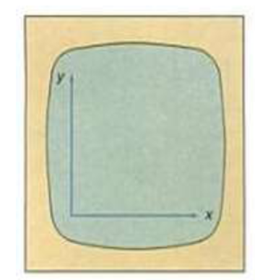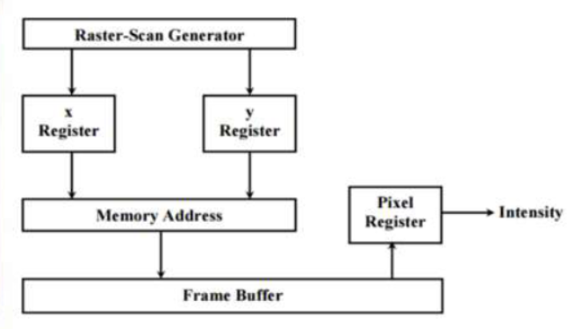
Fig: Basic Video Controller Refresh Operation
- Two registers are used to store the coordinates of the screen pixels; x register is used to store x coordinate and y register is used to store y-coordinate.
- The intensity value is stored in the frame buffer for this pixel position is then retrieved and used to set the intensity of the CRT beam.
- Initially the x-register is set to 0 and the y register is set to ymax. Then the x-register is incremented by 1,
- and the process repeated for the next pixel on the top scan line until x = xmax.
- This process is repeated for each pixel along the scan line.
- After the last pixel on the top scan line has been processed, the x-register is reset to 0, and the y-register is decremented by 1.
- This process is repeated for each successive scan line until the bottom scan line where y=0.
Random or Vector Display System
- In random scan system, the display monitor (CRT) has the electron beam that is directed only to the parts of the screen where the picture is to be drawn.
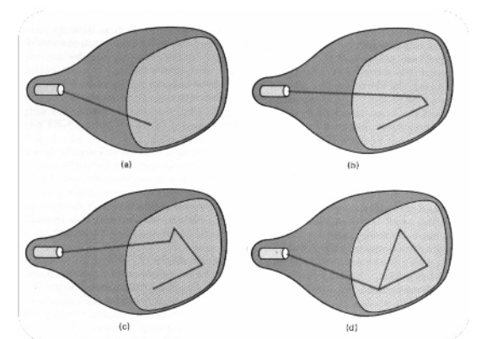

- It draws a picture with one line at a time, so it is also called vector display (or stroke writing or calligraphic display).
- The component lines of a picture are drawn and refreshed by random scan system in any specified order.
- Picture definition is now stored as a set of line- drawing command in an area of memory called refresh display file or simply refresh buffer.
- To display a specified picture, the system cycles through the set of commands in display file, drawing each component in turn.
- After all line drawing commands have been processed, the system cycles back to the first line drawing command in the list.
- Random scan system is designed for line drawing application so they can’t draw realistic shaded scene because picture definition is stored as a set of line drawing commands no as a set of intensity values.
- Vector display system produce smooth line drawing because electron beam directly follow the line path but in case of raster system, it produces jagged lines.
- Vector display system only works with high end processor.
- For vector system, refreshing a complex image with many line may cause flickering effect but this is not the case in raster system.

Architecture for Random Scan System
- The organization of simple Random scan system is shown in the figure below.

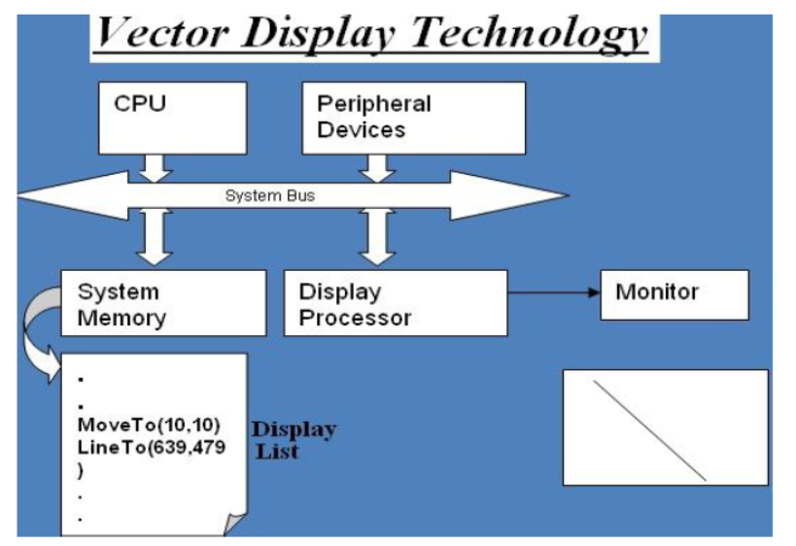

- An application program is input and stored in the system memory along with the graphics package.
- The graphics command in the application program is translated by the graphics package into a display list stored in system memory.
- The display list is accessed by the display processor to refresh the screen.
- The display processor cycles through each command in the display list once during each refresh cycle.
- Graphics pattern are drawn by directing the electron beam along the component lines of the picture.
- Lines are defined by the values for their co-ordinate endpoints.
- A scene is then drawn one line at a time by positioning beam to fill in the line between specified endpoints.

Solved Problems
- A system with 24 bits per pixel and resolution of 1024 by 1024. Calculate the size of frame buffer (in Megabytes)
Solution:
Resolution = 1024 * 1024
Total number of pixel = 1024 * 1024 = 1048576pixels
Bits per pixels’ storage = 24 bits
Therefore, total storage required in frame buffer = 1048576 * 24
= 25165824bits
=25165824/8 Byte
= 25165824/(8 * 1024) Kb
= 25165824/(8 * 1024 * 1024) Mb
= 3 Mb

- How Many k bytes does a frame buffer needs in a 600 x 400 pixel?

Suppose, n bits are required to store 1 pixel.
Then, the size of frame buffer = Resolution * bits per pixel
= (600 * 400) * n bits
= 240000 n bits
= 240000 n kb / (8 * 1024)
= 29.30 n k bytes.

- Consider a RGB raster system is to be designed using 8 inch by 10-inch screen with a resolution of 100 pixels per inch in each direction. If we want to store 8 bits per pixel in the frame buffer., how much storage in bytes do we need for the frame buffer?
Solution:
Size of screen = 8inch * 10inch
Pixels Per inch (Resolution) = 100
Then total number of pixels = 8 * 100 * 10 * 100 = 800000 pixels
Bits per pixels’ storage =8
Therefore, total storage required in frame buffer = 800000 * 8 bits
= 6400000bits
I = 6400000/8 bytes
= 800000Bytes

- Find out the aspect ratio of the raster system using 8 x 10 inches’ screen and 100 pixels/inch.
Solution:
We know that, Aspect ratio = Width / Height
= (8 x 100) / (10 * 100)
= 4 / 5
So, aspect ratio = 4: 5

- What is the time required to display a pixel on the monitor of size 1024 * 768 with refresh rate of 60 Hz?
Solution:
Refresh Rate = 60Hz i.e. 60 frames per second
Total number of pixel in one frame = 1024 * 768 = 786432 pixels.
60 frames need 1 second
1 frame need 1 / 60 second
i.e. 786432 pixels need 1/ 60 second
hence, 1 pixels need 1 / (60 * 786432 ) second
= 10⁹ / (60 * 786432) ns
= 21.19 ns

- If the total intensity achievable for a pixel is 256 and the screen resolution is 640 * 480. What will be the size of frame buffer?
Solution:
1 pixel =256 different intensity level
Resolution = 640 * 480
Let X be the number of bits required to represent 256 different intensity level
Then, 2^{X} = 256
Therefore, X= 8 bits
Hence, number of bits required for the screen = 640 * 480 * 8 = 2457600 bits.

- If a pixel is accessed from the frame buffer with an average access time of 300ns then will this rate produce an un-flickering effect for the screen size of 640 * 480.
Solution:
Size of screen = 640 * 480
Total Number of pixels = 640 * 480 = 307200
Average access time of one pixel = 300ns
Therefore, total time required to access entire pixels of image in the screen =307200*300
= 92160000 ns
= 92160000/10⁹
= 0.09216 seconds

i.e. 1 cycle take 0.09216 second
now, Number of cycles per second i.e. Refresh Rate =?
0.09216 seconds = 1 cycle
1 second = 1/ 0.09216
= 10.86
Therefore, Refresh Rate= 10.86 cycles per second
Since the minimum refresh rate for unflicker image is 60 frames per second, hence we can say the monitor produces flickering effect.

- Consider a raster scan system having 12-inch by 10-inch screen with a resolution of 100 pixels per inch in each direction. If display controller of this system refresh the screen at the rate of 50 frames per second, how many pixels could be accessed per second and what is the access time per pixel of the system.
Solution:
Size of Screen = 12inch * 12inch
Resolution: = 100pixels per inch
Therefore, total number of pixels in one frame = 12 * 100 * 12 * 100
Refresh Rate = 50 frames per second i.e. 50 frames can be accessed in 1 second
Therefore, total number of pixel accessed in 1 second = 50 * 12 * 100 * 12 * 100
= 72000000 pixels.
Again,
Since, 50 frames can be accessed in 1 second
1 frame can be accessed in 1/50 second
i.e. (12 * 100 * 12 * 100) pixels can be accessed in 1/50 second
then 1 pixel can be accessed in 1 / (50 * 12 * 100 * 12 * 100) second
= 10⁹ / (50 * 12 * 100 * 12 * 100) ns
=13.88 ns
Hence, Access time per pixel = 13.88ns/pixel.

- How much time is spent scanning across each row of pixels during screen refresh on a raster system with resolution 1280 * 1024 and refresh rate of 60 frames per second? (TU Exam)
Solution:
Resolution = 1280 * 1024 i.e. One frame contains 1024 scan line and each scan line consists of 1280 pixels.

Refresh Rate = 60 frames per second
i.e. 60 frame take 1 second
1 frame take 1/60 second
i.e. 1024 scan line take 1/60 second i.e. 0.0166 second
1 scan line take 0.0166/1024 = 0.016 Ms.

- What is the size of frame buffer required to store a SVGA with 24-bit true color video of 10 minute without compression?
Note: A digital movie is a sequence of video frames in which each frame is a full color still image.
Resolution Info of different Display Hardware
SVGA: 800 * 600 (Super Video Graphics Array)
VGA: 640 * 480 (Video Graphics Array)
XGA: 1024 * 768 (Extended Graphics Array)
HD720: 1280 * 720 (High Definition)
HD1080: 1920 * 1080

Solution:
For SVGA, Resolution = 800 * 600
Refresh Rate = 60Hz i.e. 60 frames per second
So each second can play 60 frames

Total number of pixel in one frame= 800 * 600
Bits per pixel = 24 bit
Therefore, total storage required for one frame buffer = 800 * 600 * 24 bits

Now how many frame buffer required for 10 minutes’ videos?
10 minutes = 10 * 60 seconds = 600 seconds
Then, size of frame buffer for 1 second = 60 * 800 * 600 * 24 bits
Hence, size of frame buffer for 600 seconds i.e. 10 min video = 600 * 60 * 800 * 600 * 24 bit
= 48.27 GB

- Differentiate between raster and random display system.

